**MAJOR PROJECT – II**

**SYNOPSIS REPORT**

**ON**

**HOPE (University Blood Donation Application)**

**Submitted By**

| **ANUBHAV DESHWAL** | **ANKUR SEHRAWAT** | **AKSHAT KAUSHIK** | **DEEPEN LAKRA** |
| --- | --- | --- | --- |
| **500069112** | **500069044** | **500067066** | **500069625** |

Under the guidance of

**Dr. Sonali Vyas**

Assistant Professor



**Department of Cybernetics,**

**School of Computer Science**

**UNIVERSITY OF PETROLEUM AND ENERGY STUDIES**



**School of Computer Science**

**UNIVERSITY OF PETROLEUM AND ENERGY STUDIES**

**Synopsis Report**

**Major: 2**

**Project Title:** **HOPE -** University Blood Donation Application

**Abstract:**

There is an expectation that the blood will always be there when it is really needed. Blood donor volunteers constitute the main supply source in an effective blood supply chain management. They feed blood stocks through their donation. In an emergency situation, if the stocks are insufficient, the only source of blood supply will be the people who come to the health center and donate the blood on a voluntary basis. It is certain that time is a very important component in such a situation. For this reason, the health care center should call the nearest available donor in order to ensure to get the service as quickly as possible. A smart phone application is developed to facilitate the identification of the nearest available blood donor volunteer and the communication with him/her in the emergency situations where the blood can’t be supplied through the blood banks’ stocks. This Application mainly focuses on Students encouraging them to participate in blood donation camps in university itself and in case of medical emergencies providing help through this application.

**Keywords:** Hope Application , Blood donation system , HealthCare.

**Table Of Content**

| **S.No.** | **Topic** | **Page No.** |
| --- | --- | --- |
| **1.** | Project Title | 2 |
| **2.** | Abstract | 2 |
| **3.** | Introduction | 3 |
| **4.** | Literature Review | 4 |
| **5.** | Problem Statement | 6 |
| **6.** | Objective | 6 |
| **7.** | Work Done | 7-11 |
| **8.** | UML Diagram | 12-13 |
| **9.** | Methodology | 14-15 |
| **10.** | System Requirements | 15 |
| **11.** | Schedule | 16 |
| **12.** | References | 17 |

**Introduction:**

Blood and its parts are imperative for human existence as there's no substitute for human blood. No major operation will be performed while not the utilization of blood in any hospital or clinic. Since India has a huge population, the requirement of blood is rising on a daily basis. According to the survey conducted by World Health Organization (WHO), India wants eight crore units of Blood, however solely ten lakhs’ units are available on the market, that shows the intense shortage of blood.

Every day, at least 2,000 donations are needed on average, but the remainder are not enough. Things such as traffic crashes, hospitalization, birth of children etc. still want external blood supplies in an emergency. The barrier between individuals in need of blood would be reduced by blood-base applications.

**Literature Review:**

Blood transfusion is a critical element of health care. It contributes to saving ratings of lives yearly in each ordinary and emergency thing. Furthermore, it dramatically improves the anticipation and excellent lifestyles of patients with a number of acute and continual conditions. Blood transfusion helps voluntary blood donation. During the ensuing five-10 years, the delivery of blood is important to meet the stress of older populations. In addition, in the case of operation or treatment, medical institution employees ask the affected individual's cherished ones for blood donation or family need to be forced to be conscious of some donor who has the compatibility of the blood type with the affected person. This emergency scenario increases numerous demanding situations are trying to find out the donors. New techniques have to meet the demands of society.

A Geo-localized Blood Donor Management System [3] As an alternative technology, it employs Mobile Crowdsourcing. This is the practice of requesting or distributing a task to a wide number of individuals. Crowdsourcing systems that enlist a vast number of individuals to help solve a diverse range of problems. It gathers millions of users to create an item that would benefit the whole society. Crowdsourcing can be linked to a wide range of topics, and it poses a number of intriguing technological and social problems.

M-Health [4] It is a new wellness horizon that provides healthcare facilities through mobile devices and networking technology. Blood donation in health care is a complicated procedure that takes months to select a donor that has the same blood pool as the recipient. Android-based blood donation application is an M-Health solution to connect the requester and donor at any time and from any place.

The Android Smartphone Blood donation application [5] is an android-based total blood donation utility that keeps the information of blood donor volunteers. In instances of an emergency, the request can transmit the message to all eligible donors for donation, together with records from the blood institution and clinic. They used the cloud hosting infrastructure to keep application data anywhere and at all times. It is also a voluntary blood donation as a requesting applicant that is the superior attribute of our submission. The requester can transmit the message to the registered users along with an emergency sign for the blood needed, and a message will be transmitted to all voluntary donors of blood. When a volunteer confirms the donation of blood, it is recognized as a donor. Our software supports the collection of blood donations and ensures careful handling of the emergency situation

**Problem Statement:**

There is a lack of awareness and a negative attitude towards blood donation among a considerable percentage of students. This results in poor participation in blood donation among this population. Therefore there is a critical need for culture university students to be aware and improve their attitude towards blood donation.

Also students living away from their families may have medical emergencies. During such times getting quick help is difficult as they don’t have enough contacts. Such situations are stressful and asking for help is time consuming.

**Objective:**

The objectives of this project are.

1. To create an effective digital solution.
2. Reaching a large number of people in an emergency to find blood.
3. Find active blood donors and other information about them.
4. Able to track when a student last time donated.
5. Able to book appointments with blood banks according to your schedule.
6. Quick Registration through application.
7. Spreading Awareness about healthcare.

Work Done:



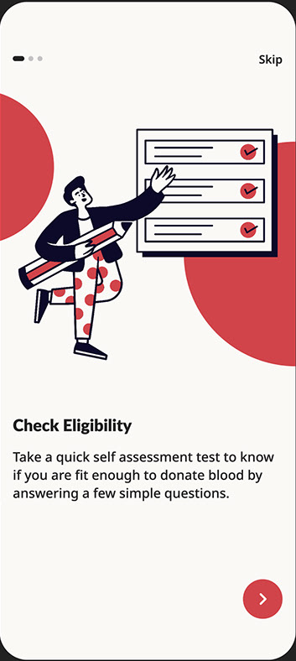 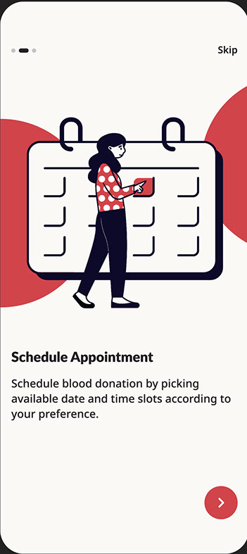 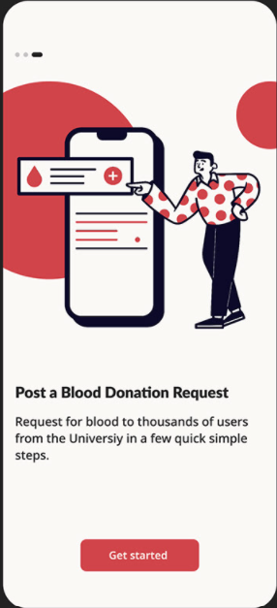





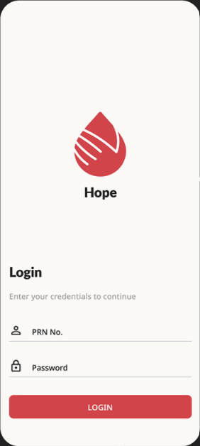 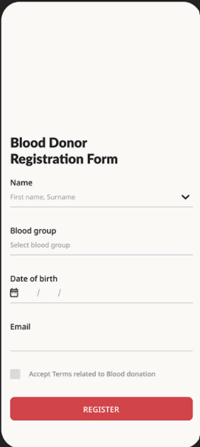 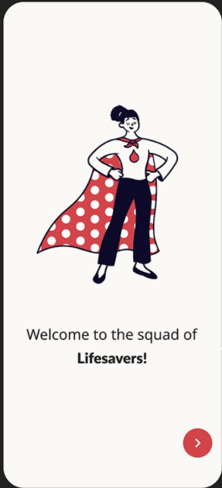



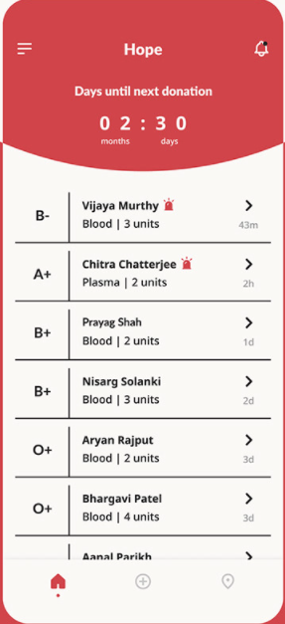





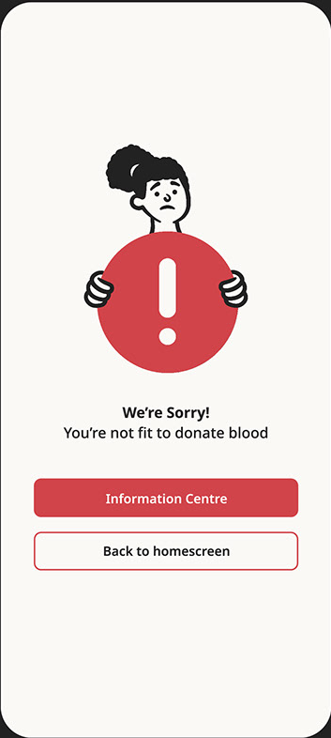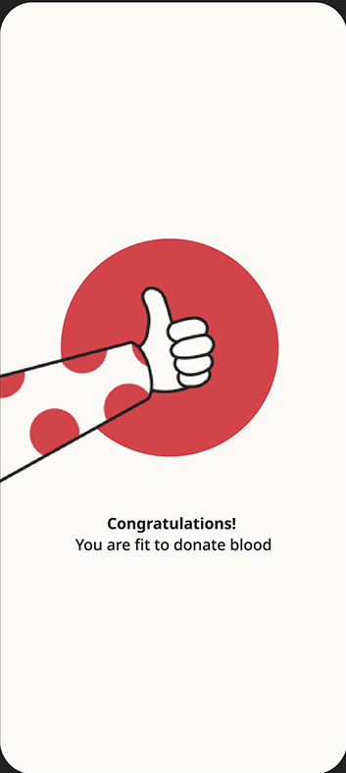





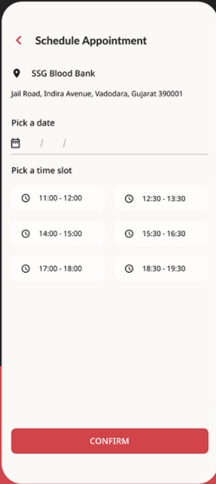



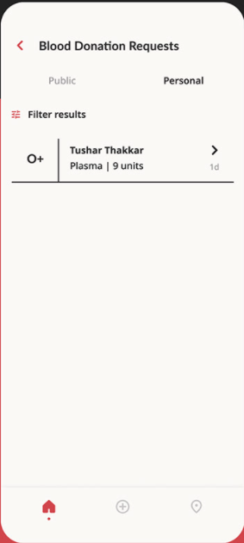

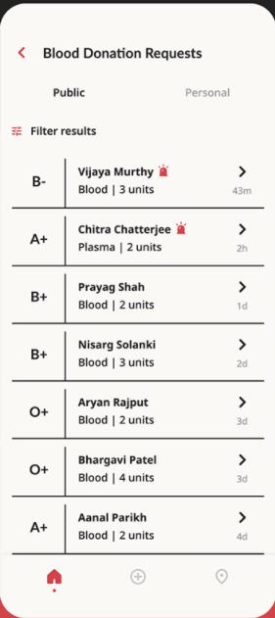

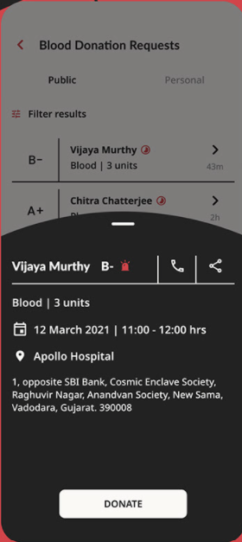







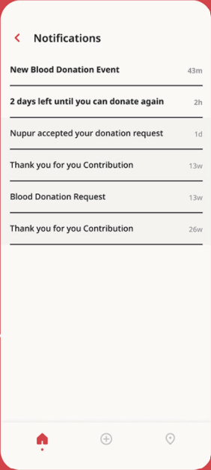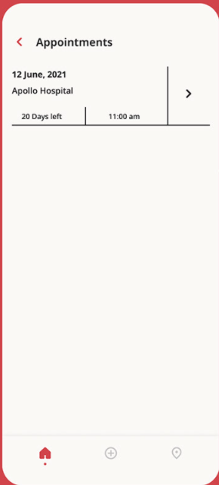

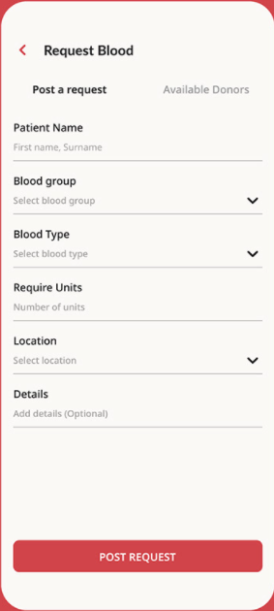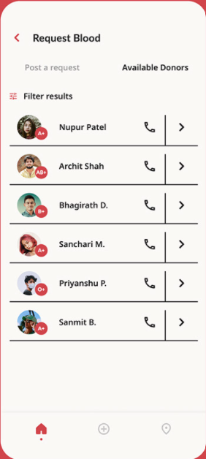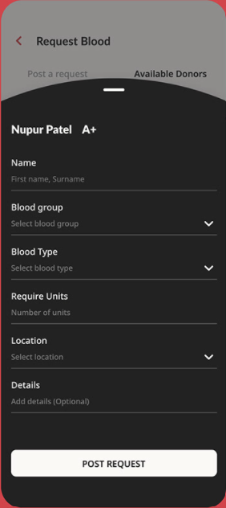

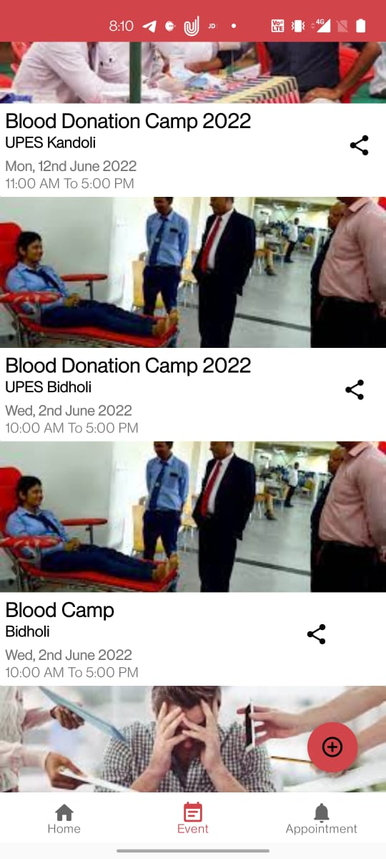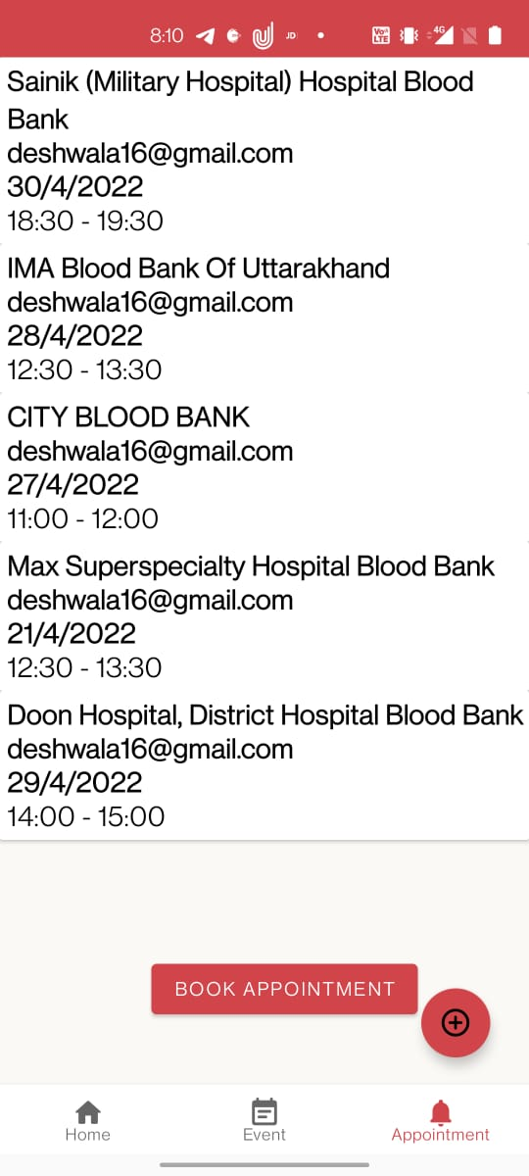

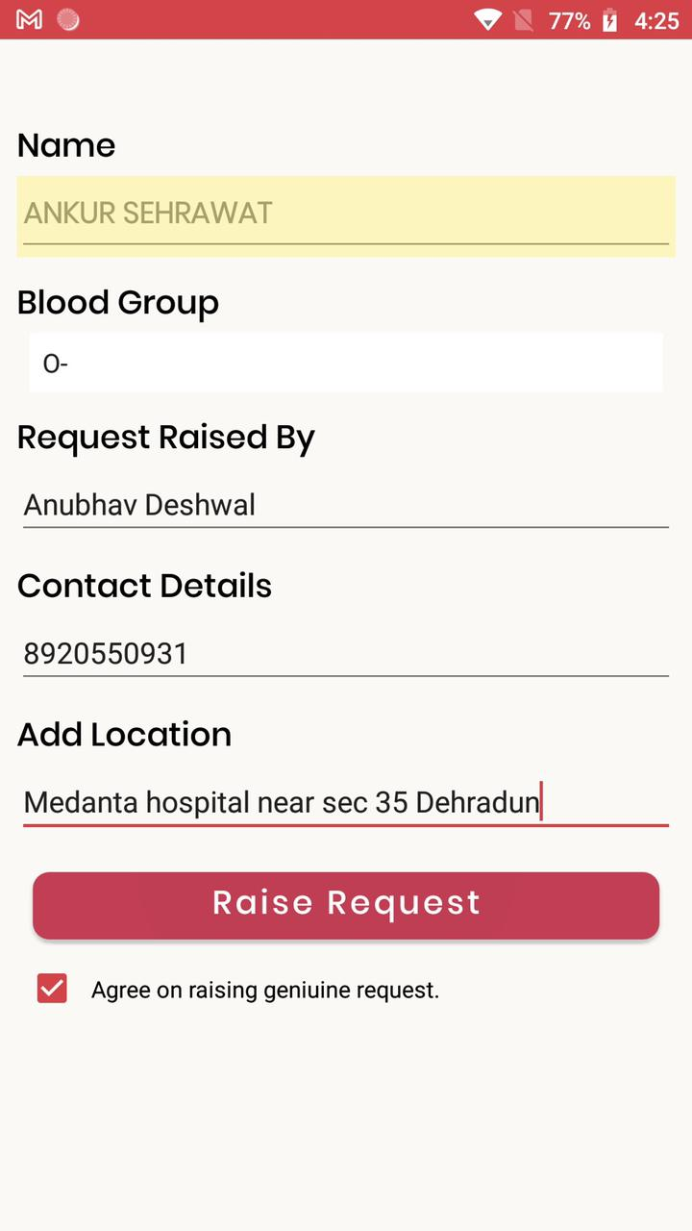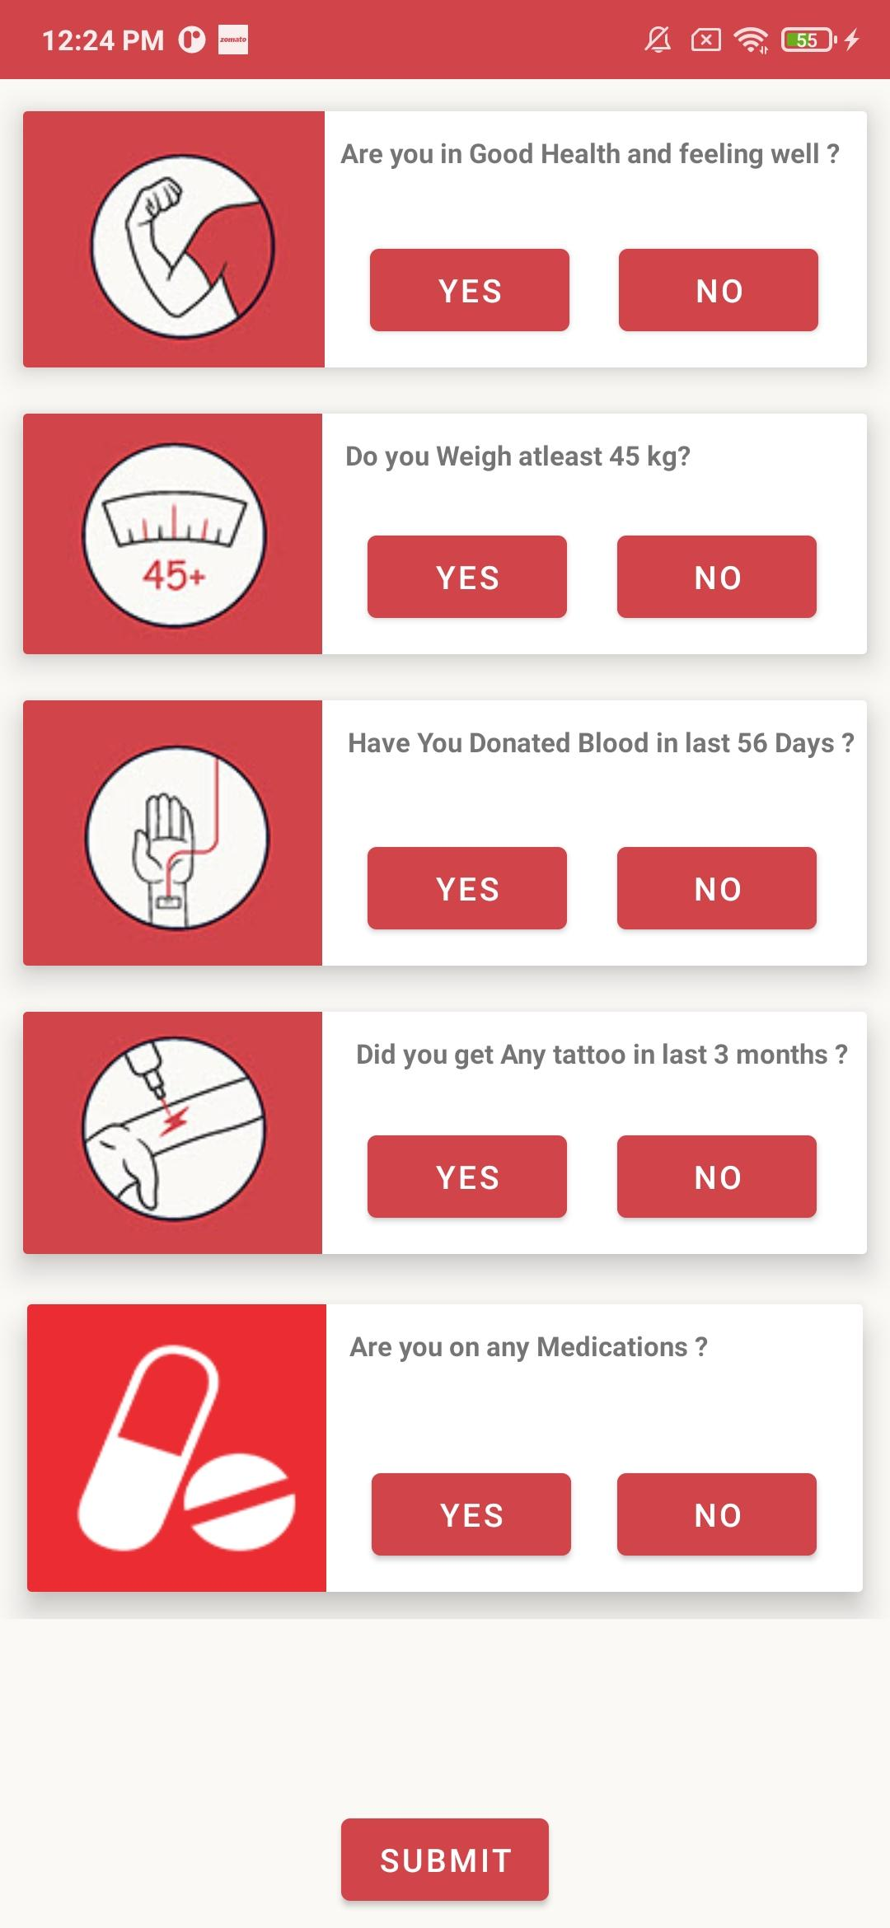

**Information Application Architecture:**

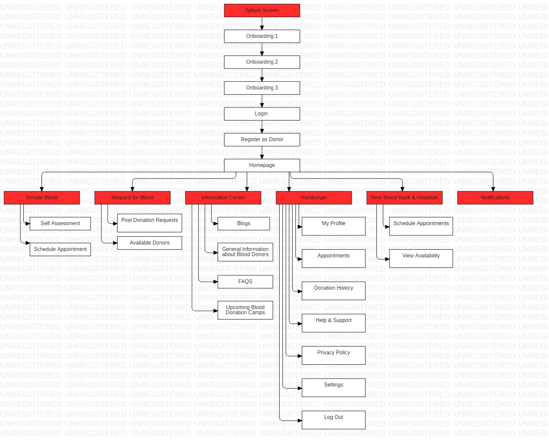

This Architecture determines the application features and the workflow of different segments.

**User Flow Diagram**

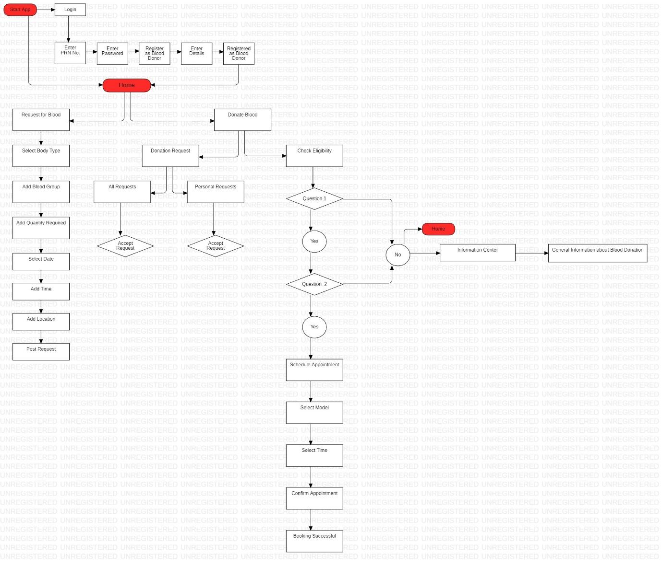

This Diagram shows user flow in the application.

**SUMMARY:**

We planned to establish an effective digital solution for blood donation for our project: HOPE. We've created a platform that allows us to identify blood donors and even donate blood through a blood donation camp listed on our app. This can be accomplished by taking the following steps:

1. The user must first register and then login to our app.
2. After logging in, the user will be required to take a simple self-assessment test.
3. After passing the exam, the user must meet an eligibility condition for blood donation, which is based on previous blood donation history and whether or not the user has any ailments.
4. If the user wants to donate blood, he or she can go to the events area and schedule an appointment for the nearest blood donation drive at a time that is convenient for them.
5. If a user needs blood and needs it now, he or she can go to the raise an issue tab and look for nearby blood donors who match the appropriate blood group.

**Methodology:**

To implement this project, the methodology used is based on the System Development Life Cycle (SDLC), generally, four major steps, which are Planning, Analysis, Design and Implementation. explained in below fig.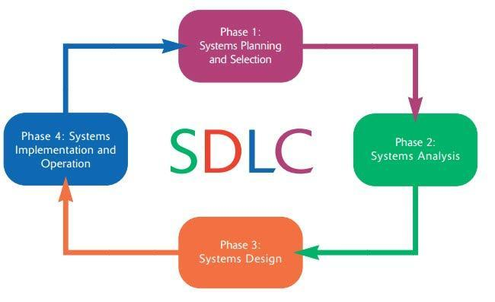

**1. Planning Phase**

During the planning phase, we conducted some series of tasks which are listed as follows; select project topic, identify problems of the current system, defined project objectives and scope of the proposed system, conduct feasibility studies, project work plan, develop a time schedule (Gantt Chart) and prepare project proposal. The focal point of the planning phase is to understand why a system is being developed to implementation stage.

**2. Analysis Phase**

At this stage analysis is driven by business concerns, specifically, those of system users. Hence, there is a need for the existing chatting system and the definition of chatting requirement and priorities for a new or improved system and also for the purpose of understanding what, why, and how the system can be implemented.

**3. Designing Phase**

During the design phase, the system and software documents are designed as per the requirements identified. The activities involved in the design phase are:

1. System Architecture

2. System Design

**4. Implementation Phase**

At this stage of development, testing the system functionality with relevant test data and providing user manual for the proposed system will be put into consideration. System data and functionality testing will be conducted with validation made.

**System Requirements:**

**Hardware Requirements:**

**For USER**

* An Android phone
* 2 GB Minimum RAM Required
* Mobile Data or Wi-Fi Connectivity

**For DEVELOPER**

* A personal computer
* 8 GB Minimum RAM Required
* Internet Connection

**Software Requirements:**

* Android Studio
* Operating System (Windows/Linux/Mac OS)

**SCHEDULE: (PERT Chart)**

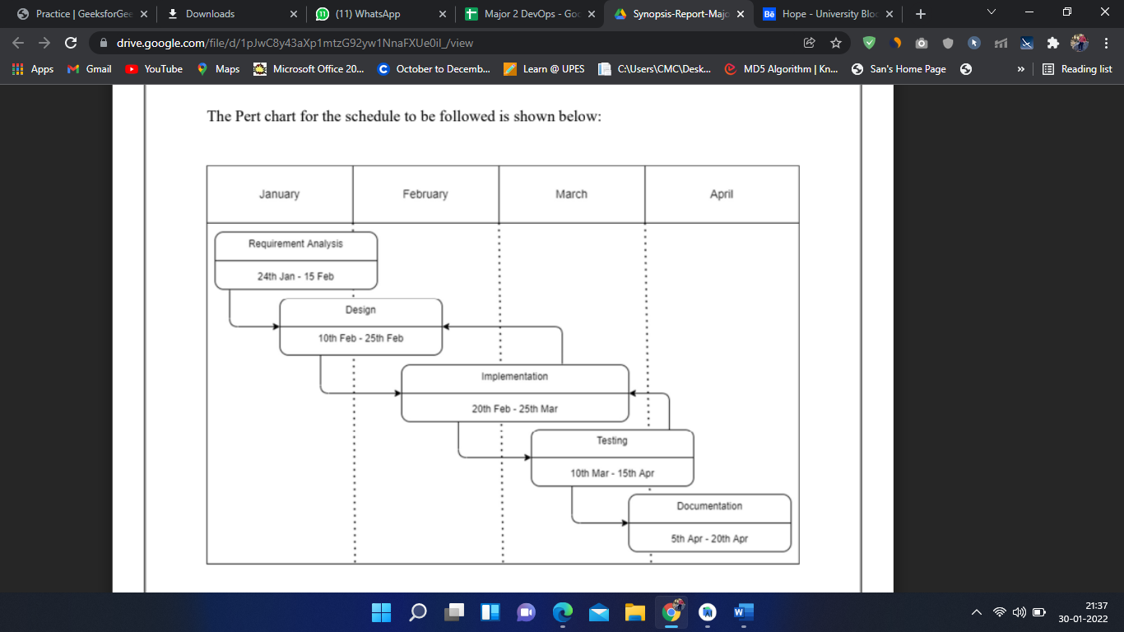

**REFERENCES:**

1. <https://www.researchgate.net/publication/349000171_DEVELOPMENT_OF_A_BLOOD_BANK_INFORMATION_RETREIVAL_SYSTEM_USING_ANDROID_APP>
2. <https://ijcrt.org/download.php?file=IJCRT2105420.pdf>
3. <https://ieeexplore.ieee.org/document/9378752>
4. <https://www.behance.net/gallery/133465165/Hope-University-Blood-Donation-App>

**Approved By:**

**Mrs. Nitika Goenka Dr. Sunil Gupta**

Project Guide Head of Department

Department of Cybernetics School of Computer Science